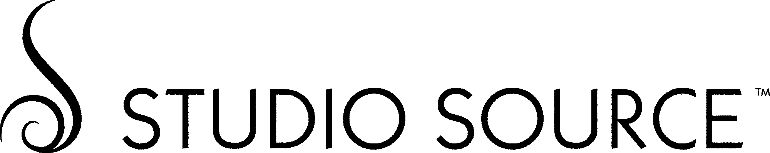

Pattern Name: Pearls Night Out

Pattern Series TC4618 – TC4629 Physical Properties:
Type II • 20 oz. Width: 52”/54”
Random Repeat / Reversible Match Total Weight (oz./lin.yd): 20.3 oz.
Cinch Emboss Total Weight (oz./sq.yd): 13.0 oz.
Fabric Type: Poly Cotton Osnaburg
Federal Specifications: CCC-W-408A/D, Type 2 Backing Fabric Weight: 1.8oz./sq.yard
Average Total Thickness: 16mils
Fire Testing:
Tested in accordance with ASTM E-84 Tunnel Test
Class A Fire Rated
Flame Spread: Class A
Smoke Developed: Class A

York Quality Standards
- LOW IN V.O.C.’S
INDOOR AIR QUALITY – Low V.O.C. emitting vinyl wallcoverings meets California Department of Health Services section 01350 requirements for office and school interior
- LEED CONTRIBUTION – Can contribute to LEED EQ 4.1 for low-emitting materials, adhesives and sealants, if used with low V.O.C. adhesives.
- SUSTAINABLE MATERIALS – Printed with water based inks.
- ENERGY SAVINGS – Improves insulation R-factor by up to 6%
- STAIN AND MILDEW RESISTANCE – Best rating (0) as tested in accordance with G.S.A. Federal Specification CCC-W-408A/D
- ANTI-MICROBIAL – All of our vinyl wallcoverings contain bactericide and mildew inhibitors to discourage the growth of mold and mildew under normal conditions.
- WARRANTY – 5-year limited warranty against manufacturing defects. Additional information available at www.yorkcontract.com

Customs
Available upon request

Environmental Statement:
York Wallcoverings has always sought to be a responsible neighbor as well as a steward of the earth’s natural resources. York continues toward its goal of giving the healthcare, hospitality and corporate wallcovering users environmentally superior choices. We are dedicated to complying with today’s environmental issues, and have eliminated all heavy metals such as lead, mercury, cadmium and chromium from our inks and adhesives.

Permeability:
This product is intended for use in buildings designed and maintained to avoid moisture accumulation on or within walls, particularly in warm, humid climates. The features that make vinyl wallcovering so cleanable and durable also render it very low in permeability. Vinyl wallcovering products should not be installed on walls that contain excessive moisture or are subject to moisture infiltration (more permeable products should be considered for use under such conditions). If mold or mildew is present, or if walls show moisture damage or have excess moisture content, do not proceed with installation. Moisture infiltration and water vapor in and behind the wall must be eliminated for proper performance. Processes that increase permeability, including microventing, should be considered for use under certain conditions. In addition, the use of a mildew inhibitor in the primer and adhesive is highly recommended. Primers and adhesives with the highest possible permeability rating are also highly recommended. After installation, the walls and wallcoverings should be monitored for potential moisture or water vapor infiltration and accumulation. Any such infiltration or accumulation after installation must be promptly eliminated.

NOTE: The assigned numerical reading and other tests referenced in this text are not intended to reflect hazards presented by this or any other material under actual fire cognitions. Consult an architect or fire safety engineer for information on applicable building codes and reduction of fire hazards, including the use of sprinklers. Wallcoverings should only be cleaned with mild ingredients such as soap, detergent and water. Stronger, alkaline household cleaners have the potential to damage the surface of the wallcoverings, as does excessive scrubbing.

Design Copyright © York Contract Revised: 07/2014

